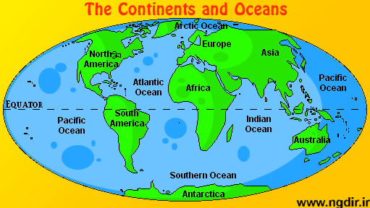
Name _____________________________ Date ________________ Class ____________________
Label the continents and oceans using the word bank below.
BONUS: Southern Ocean
Equator
Antarctica Australia Indian Ocean Asia Arctic Ocean Africa
South America Europe North America Atlantic Ocean Pacific Ocean (use twice)

Label the 8 main physical features in the United States using the word bank below.
Atlantic Coastal Plains Continental Divide Great Basin The Great Lakes (Huron, Ontario, Michigan, Erie, Superior)
____ ____ ____ ___ ____
Great Plains Death Valley St. Lawrence River Gulf of Mexico

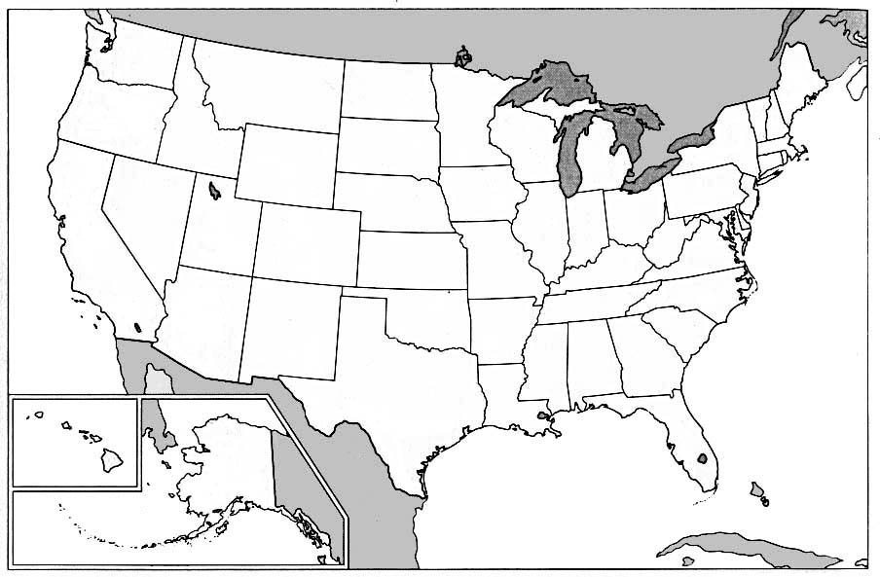
5
4
3
2
1

